Hi,

I am not able to upload the Zip folder and submit the project. Below is the error i am facing.

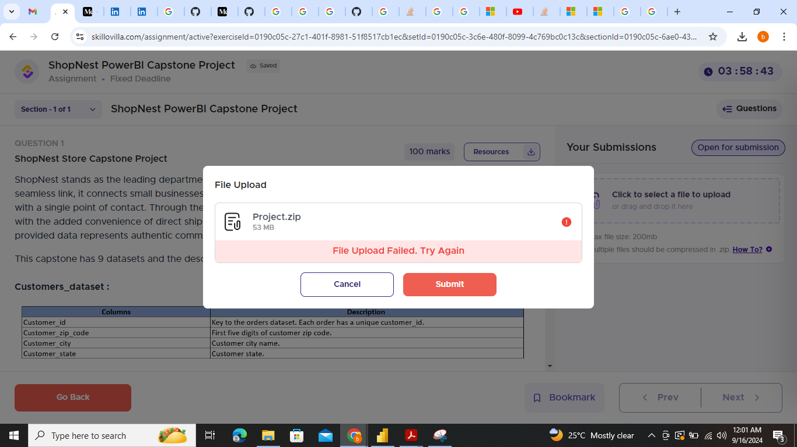

Therefore, I am uploading the same over Google drive and sharing the link here - <https://drive.google.com/file/d/1F0P2cQNQthF3x03PZDvJNiyHEJqL9cSO/view?usp=sharing>. Requesting you to upload this project from your end.